**Food Town Saga Build Guide**

**1. How to build**

*Open Projects and choose File Menu, select “Build Settings...” (shortcut key: Ctrl + Shilf + B)Press Player Settings... button on Build Settings dialog to open PlayerSettings on Inspector windows*

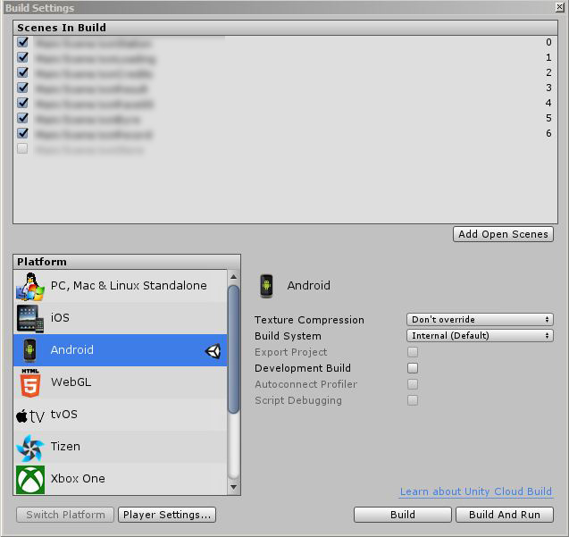

*On PlayerSettings window, fill/change information if need, press Browse Keystore to add your keystore, fill password, choose Alias & fill password for that alias*

*After all build settings is set, press Build in Build Settings window and enter file name in Save dialog to start building*

*Waiting for building process complete to receive an apk file, this file is ready to publish*

**2. Change the game graphics & sounds:**

- All graphics are stored in **Asset/ _Resources** folder, after you have made new graphics just simply replace the old one with the new one.

- All sounds are stored in **Asset/_Resources** **/Sounds** folder, replace sounds by the new one.

**3. Change advertisement ID**

- Advertisement ids are stored in **Asset/Scripts/GoogleAdmob.cs** script file. Open it and change the Ads ids.

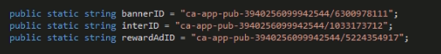

**4. How to change Level Setting:**

- Open Asset/Resources/World1_LevelSettings_data.json file and change the level information. All fields are self explained.

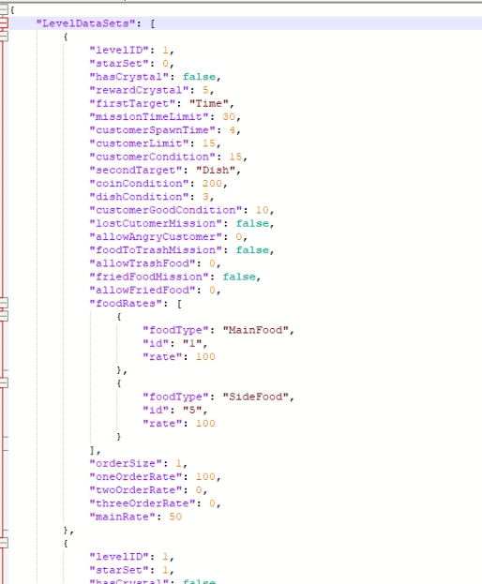

**5. More Support**

- Please don’t hesitate to leave a comment at our source to ask for support.

- If the sources are good, please give us 5 stars rating to help us bring more high quality products.

- Thank you for purchase our source.